Lab1-Basic and Vectorized Programming of Matlab

CIS694/EEC693 Image Processing and Learning Methods-2021 Spring

By Hongkai Yu, [h.yu19@csuohio.edu](mailto:h.yu19@csuohio.edu)

Cleveland State University

1. Suppose you have two 1000D feature vectors V1, V2.

V1 = rand(1000,1);

V2 = rand(1000,1);

(A) Use a FOR Loop to compute L1 and L2 distance between V1 and V2.

(B) Use vectorized programming to finish Task A without Loops.

Refer to: https://www.cs.utah.edu/~jeffp/teaching/cs5955/L7-Distances.pdf

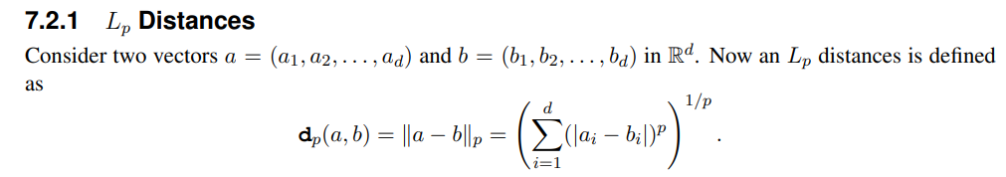

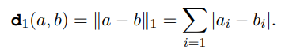

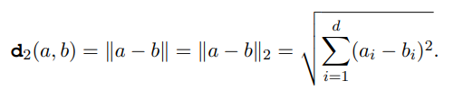

After programming, please think about its potential applications.

2. Suppose you have a folder named “Input” containing many images (>2000) of JPG format, and you have another empty folder named “Output”.

Write a Matlab code to process each image in the “Input” folder to be Quarter-sized image of PNG format and save the processed image into the “Output” folder.

Input: x1.jpg, x2.jpg, …

Output: x1.png (half height and half width of x1.jpg), x2.png (half height and half width of x2.jpg), …

Note that each image in the “Input” folder might have different size.